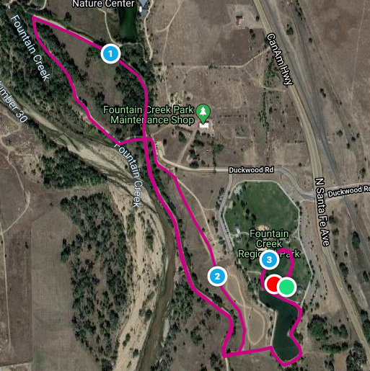
Fountain Creek Regional Park 5K Course Map

Mile 1 follows the west-most trail north, then stays on the east (right) side after the cross roads. Runners complete the top loop of the “figure 8” in a counter-clockwise direction, then keep right at the crossroads to head south on the same trail runners took north for mile 1. The 2-mile mark is on the east side of the bottom loop of the “figure 8,” which is also run in a counter-clockwise direction. Mile 3 completes the bottom loop of the “figure 8” then heads back around the pond and onto grass fields where the race started.

